**GYM MEMBERSHIP BOOKING AUTOMATION**

#### 

#### A PROJECT REPORT

***Submitted by***

# HINDUSHA K (220701092)

***in partial fulfillment for the course***

#### OAI1903 - INTRODUCTION TO ROBOTIC PROCESS AUTOMATION

***for the degree of***

# BACHELOR OF ENGINEERING

#### in

**COMPUTER SCIENCE AND ENGINEERING**

# RAJALAKSHMI ENGINEERING COLLEGE RAJALAKSHMI NAGAR

**THANDALAM CHENNAI – 602 105**

#### NOVEMBER 2024

RAJALAKSHMI ENGINEERING COLLEGE CHENNAI - 602105

# BONAFIDE CERTIFICATE

Certified that this project report **“GYM MEMBERSHIP BOOKING AUTOMATION”** is the bonafide work of **“HINDUSHA K(220701092)”** who carried out the project workfor the subject OAI1903-Introduction to Robotic Process Automation under my supervision.

#### Mrs. J. Jinu Sophia, M.E. (Ph.D.),

Assistant Professor (SG),

Department of Computer Science and Engineering Rajalakshmi Engineering College

Rajalakshmi Nagar Thandalam Chennai - 602105

Submitted to Project and Viva Voce Examination for the subject OAI1903-Introduction to Robotic Process Automation held on .

#### ABSTRACT

The **Gym Membership Booking Automation** is an RPA-based solution developed using UiPath to streamline and automate the process of booking gym sessions for members. This system eliminates manual intervention by enabling users to select sessions, confirm availability, and receive booking confirmations efficiently.

The workflow starts by collecting user inputs, including the session name, member name, email, and session date, through Input Dialogs. It then checks session availability from an Excel file containing session details, such as available slots. The bot generates a unique OTP for authentication, sends it to the user's email, and validates the entered OTP to ensure secure bookings.

Once validated, the bot reduces the available slots in the session record, adds the booking details to a separate database, and updates the Excel file accordingly. It then sends a personalized email confirmation to the user with session details, including the booking time and date.

This project leverages key UiPath activities, such as Read Range, Filter Data Table, and Send SMTP Mail Message, to interact with Excel and email services. The bot is designed to provide a seamless experience, improving operational efficiency and reducing errors associated with manual booking processes.

The Gym Membership Booking Automation is particularly beneficial for gyms or fitness centers handling large volumes of bookings. By automating the gym membership process, delivers a practical and reliable solution to improve member satisfaction .

#### ACKNOWLEDGEMENT

Initially we thank the Almighty for being with us through every walk ofour life and showering his blessings through the endeavour to put forth this report. Our sincere thanks to our Chairman **Thiru. S.Meganathan, B.E., F.I.E.,** our Vice Chairman **Mr. M.Abhay Shankar, B.E., M.S.,** and our respected Chairperson **Dr. (Mrs.) Thangam Meganathan, M.A., M.Phil., Ph.D.,** for providing us with the requisite infrastructure and sincere endeavouring in educating us in their premier institution.

Our sincere thanks to **Dr. S.N.Murugesan, M.E., Ph.D.,** our beloved Principal for his kind support and facilities provided to complete our work in time. We express our sincere thanks to **Dr. P.Kumar, M.E., Ph.D.,** Professor and Head of the Department of Computer Science and Engineering for his guidance and encouragement throughout the project work. We convey our sincere and deepest gratitude to our internal guides, **Mrs. J. Jinu Sophia, M.E., (Ph.D.),** Assistant Professor (SG), Department of Computer Science and Engineering for their valuable guidance throughout the course of the project. We are very glad to thank our Project Coordinators, **Dr. N.Durai Murugan, M.E., Ph.D.,** Associate Professor, and **Mr. B.Bhuvaneswaran, M.E.,** Assistant Professor (SG), Department of Computer Science and Engineering for their useful tips during our review to build our project.

**HINDUSHA K (220701092)**

# TABLE OF CONTENTS

**CHAPTER NO. TITLE PAGE NO.**

|  |  |
| --- | --- |
| **ABSTRACT** | iii |
| **LIST OF FIGURES** | **vi** |
| **1. INTRODUCTION** | **1** |
| 1.1 GENERAL | 1 |
| 1.2 EXISTING SYSTEM | 3 |
| 1.3 PROPOSED SYSTEM | 3 |
| **2. LITERATURE REVIEW** | **4** |
| 2.1 GENERAL | 4 |
| **3. SYSTEM DESIGN** | **6** |
| 3.1 SYSTEM FLOW DIAGRAM | 6 |
| 3.2 ARCHITECTURE DIAGRAM | 7 |
| 3.3 SEQUENCE DIAGRAM | 8 |
| **4. PROJECT DESCRIPTION** | **9** |
| 4.1 CREATING PROJECT | 9 |
| 4.2 PACKAGES REQUIRED | 9 |
| 4.3 PROJECT WORKFLOW | 10 |
| 4.3.1 ACTIVITIES USED | 10 |
| 4.3.2 EXPLAINING SEQUENCE | 11 |
| **5. OUTPUT SREENSHOTS** | **13** |
| **6. CONCLUSIONS** | **19** |
| **APPENDICES** | **20** |
| **REFERENCES** | **24** |

# LIST OF FIGURES

|  |  |  |
| --- | --- | --- |
| **Figure No** | **Figure Name** | **Page No** |
| 3.1 | System Flow Design | 6 |
| 3.2 | Architecture Diagram | 7 |
| 3.3 | Sequence Diagram | 8 |
| 4.3.2 | Sequence Creation | 11 |
| 5.1 | Session Input Box | 13 |
| 5.2 | Name Input Box | 13 |
| 5.3 | Email Input Box | 14 |
| 5.4 | Date Input Box | 14 |
| 5.5 | OTP from Email | 15 |
| 5.6 | OTP Input Box | 15 |
| 5.7 | Booking Mail from Email | 16 |
| 5.8 | Booking Details in Mail | 16 |
| 5.9 | Booking Details File | 17 |

## CHAPTER 1 INTRODUCTION

### GENERAL

Maintaining an efficient system for managing gym memberships and session bookings is essential in today’s fast-paced world. Manual processes often result in errors, delays, and inconvenience for both gym administrators and members. Robotic Process Automation (RPA) offers a solution to streamline these tasks and enhance the overall user experience.

The Gym Membership Booking Automation leverages RPA to simplify the process of managing gym session bookings. The system automates key operations such as checking session availability, authenticating users via OTP, and confirming bookings. This eliminates the need for manual intervention, ensuring accuracy, reliability, and time savings for both members and staff.

Built using UiPath, the project employs an Excel-based system to manage session details, including available slots and booking records. The bot dynamically collects user inputs, validates them, updates session availability, and sends personalized booking confirmations via email. These automated workflows provide members with real-time updates and assurance while minimizing administrative effort.

The project aims to deliver a seamless booking experience for gym members and improve operational efficiency. By automating repetitive tasks, gym staff can focus on providing better service.

This automation bridges the gap between user expectations and service delivery, offering a modern and user-friendly approach to fitness management.

### EXISTING SYSTEM

Current gym session booking systems often rely on manual processes or basic software tools that lack integration and automation. These systems require significant human intervention, such as manually tracking session availability, confirming bookings, and maintaining records. This leads to errors, inefficiencies, and delays in providing accurate updates to members. Moreover, manual systems fail to deliver real-time updates or personalized notifications, which can inconvenience members and reduce satisfaction.

### PROPOSED SYSTEM

The proposed system automates the gym session booking process using Robotic Process Automation (RPA), providing a reliable and efficient solution. This system integrates with an Excel-based database to dynamically manage session details, including availability and booking records. It automates key operations such as verifying user inputs, validating bookings through OTP authentication, and sending real-time confirmation emails.

By eliminating manual intervention, the system ensures accuracy, enhances member experience, and reduces administrative workload.

## CHAPTER 2 LITERATURE REVIEW

2.1 GENERAL

The application of automation in gym membership and session booking management has gained significance in recent years, driven by the increasing demand for efficient and error-free systems. Traditional methods, often reliant on manual processes or basic software, face challenges like human errors, inefficiencies, and lack of real-time updates. Robotic Process Automation (RPA) addresses these limitations by streamlining workflows, automating repetitive tasks, and enhancing the overall user experience.

In the context of gym management, existing systems commonly involve manual tracking of session availability and booking confirmations, which can result in delays and mismanagement. Software tools like spreadsheets and standalone applications, while effective for small-scale operations, are often limited in scalability and fail to deliver personalized notifications or real-time updates. Studies suggest that such systems are prone to inefficiencies, especially in high-demand environments like fitness centers.

RPA technology offers a transformative solution by automating tasks such as validating bookings, updating session availability, and sending personalized email confirmations. Unlike traditional systems, RPA enables dynamic interactions with structured data sources like Excel and facilitates seamless integration with email services. This reduces the dependency on human intervention, ensuring accuracy and efficiency in managing gym memberships.

The adaptability of RPA-based solutions is another key advantage, allowing the system to accommodate varied booking patterns and scale according to operational demands. Literature highlights the role of automation in improving customer satisfaction by ensuring timely communication and reducing errors. Furthermore, research indicates that integrating additional features like SMS notifications and web-based interfaces can further enhance the functionality and reach of such systems.

Despite its advantages, challenges remain, including addressing varied user needs and ensuring data security. The integration of cloud-based services and real-time analytics is proposed in the literature as a means to overcome these challenges, ensuring scalability, accessibility, and a user-friendly experience. This underscores the potential of RPA in revolutionizing gym management systems through efficient and reliable automation.

## CHAPTER 3 SYSTEM DESIGN

### SYSTEM FLOW DESIGN

A flowchart is a type of diagram that represents an algorithm, workflow or process. The flowchart shows the steps as boxes of various kinds, and their order by connecting the boxes with arrows. This diagrammatic representation illustrates a solution model to a given problem.

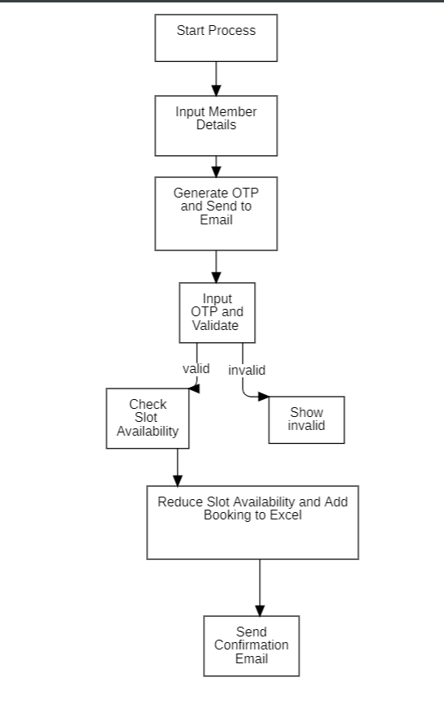

Fig 3.1 System Flow Design

### ARCHITECTURE DIAGRAM

An Architecture Diagram for the Gym Membership Booking Auomation visually represents system's components and their interactions. It highlights the user interface, processing, storage, and notification layers, showing how user details are gathered, organized in Excel, and sent via email. This diagram simplifies understanding the overall system design and flow, helping stakeholders grasp how each part contributes to the automation process.

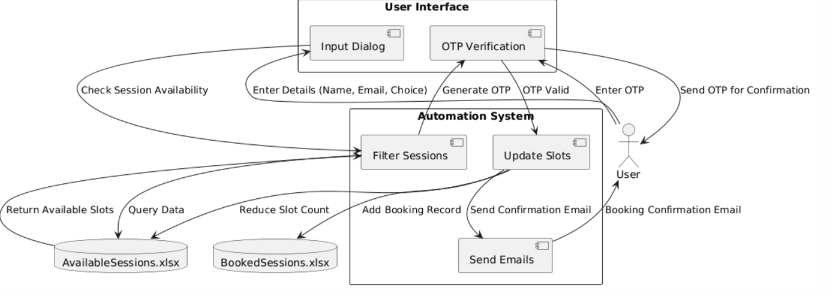

Fig 3.2 Architecture Diagram

### SEQUENCE DIAGRAM

A sequence diagram is a type of interaction diagram because it describes how— and in what order—a group of objects works together. A sequence diagram is a type of UML (Unified Modeling Language) diagram that illustrates the interactions and messages exchanged between different components or objects in a system over time. It provides a dynamic view of a system, focusing on the order of interactions between objects or components.

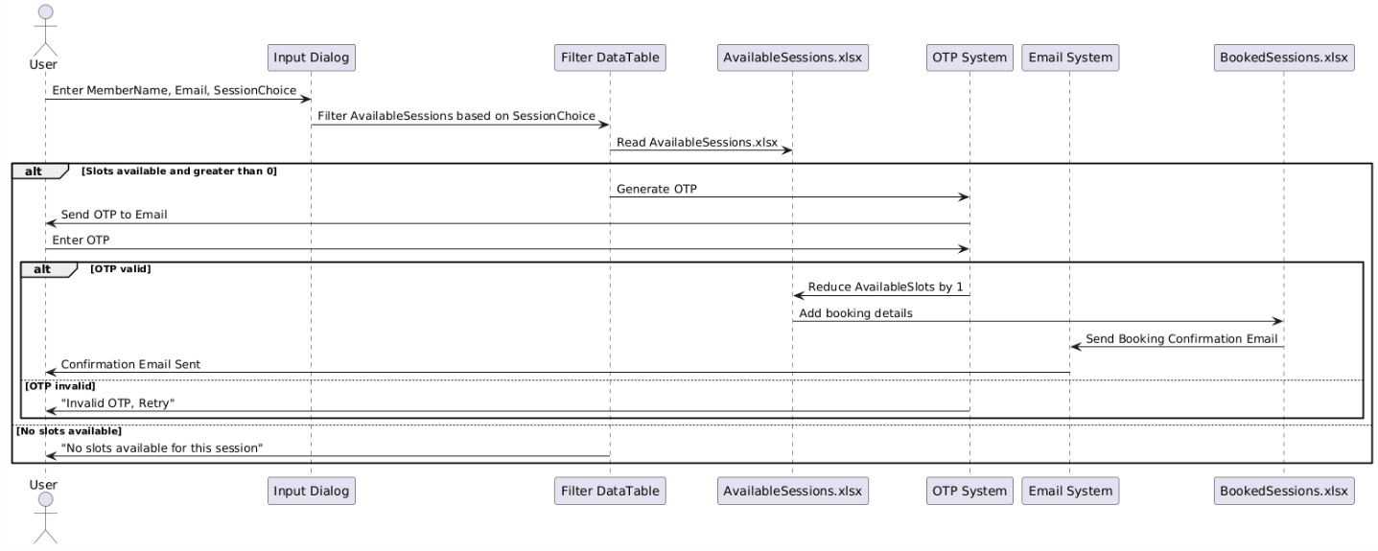

Fig 3.2 Sequence Diagram

## CHAPTER 4 PROJECT DESRIPTION

### CREATING PROJECT

Open UiPath Studio and check for the version of the application. While it’s not compulsory to work with the latest version, it is recommended as some features might have been added or few changes might have been made to the already existing Packages/Activities/Properties etc. Once the application is opened, create a new process, name the file and choose the directory where the UiPath files must be stored. Once you are done with the following steps, you will be good to continue with the next steps of actually Creating the Project.

### PACKAGES REQUIRED

For the successful completion of the Gym Membership Booking Automation, it's crucial to download the necessary packages to enable the required activities. The following packages should be installed:

UiPath.Excel.Activities: To work with Excel files and organize flight data. UiPath.Mail.Activities: For sending the Excel file via email.

UiPath.UIAutomation.Activities : For sending emails with attachments (Excel file). UiPath.System.Activities: For basic workflow automation tasks like logging & exception.

### PROJECT WORKFLOW

Now, as we know the objective of the project it is time to create the workflow that actually makes up the project. The workflow for this project is simple.

### ACTIVITES USED

To create the project the following activities are required:

* + - 1. Excel Application Scope
      2. Read Range
      3. For Each Row in Data Table
      4. Assign
      5. If
      6. Send SMPT Mail Message
      7. Message box
      8. Delay
      9. While
      10. Write Line

### EXPLAINING SEQUENCE

The project was initialized by creating a UiPath workflow and adding essential dependencies, including Excel, email, and input dialog activities. The workflow was designed to automate the end-to-end process of gym membership booking while ensuring seamless user interaction and data management.

The process began with Input Dialog activities to collect user details, including their session choice, full name, email address, and preferred session date. These details were stored in corresponding variables for use in subsequent steps.

An OTP was generated using the Assign activity, ensuring a secure and unique code for verification. The generated OTP was emailed to the user using the Send SMTP Mail Message activity. To confirm their booking, the user was prompted to enter the OTP via an Input Dialog. The entered OTP was validated using an If activity, and incorrect entries were handled with a message box alert and process termination.

Next, the session availability was verified by reading the available sessions data from an Excel file into a DataTable using the Read Range activity. The Filter Data Table activity was used to identify the row corresponding to the user’s chosen session. An If activity checked whether slots were available for the selected session. If no slots were available, the process displayed an appropriate message and terminated.

Upon confirming slot availability, the automation reduced the number of available slots by 1 in the DataTable and added the user’s booking details to a separate BookedSessions DataTable. This included information such as the user’s name, email, session choice, session date, and booking time.

Finally, the updated data was written back to the Excel file using the Write Range activity. A booking confirmation email was sent to the user with the details of their session, marking the completion of the process.

## CHAPTER 5 OUTPUT SCREENSHOTS

Fig 5.1 Session Input Box

Fig 5.2 Name Input Box

Fig 5.3 Email Input Box

Fig 5.4 Session Date Input Box

Fig 5.5 OTP from Email

Fig 5.6 OTP Input Box

Fig 5.7 Booking Confirmation

Fig 5.8 Receiving the Booking Details

Fig 5.10 Booking Details File

## CHAPTER 6 CONCLUSION

The Gym Membership Booking Automation project showcases the effective application of Robotic Process Automation (RPA) to enhance the membership enrollment and booking process for gym facilities. Using UiPath, the project automates critical tasks such as member information collection, OTP-based verification, slot availability checks, and confirmation email generation. By integrating Excel as a centralized data repository and employing activities like Filter Data Table, Write Range, and Send SMTP Mail Message, the automation delivers accuracy and efficiency in managing routine operations.

This project demonstrates the potential of RPA to streamline administrative workflows, reducing manual intervention and ensuring seamless user experiences. Its dynamic approach to handling slot reservations and personalized communication highlights its adaptability for various membership scenarios.

The automation’s successful implementation underscores its scalability and reliability, making it an ideal solution for gym owners and fitness centers aiming to improve operational efficiency and member satisfaction. With additional features such as payment gateway integration or mobile app synchronization, the system could evolve into a fully comprehensive gym management platform.

In conclusion, the Gym Membership Booking Automation project not only simplifies the booking process but also serves as a valuable example of how RPA can revolutionize administrative processes in fitness and wellness industries, paving the way for enhanced productivity and user convenience**.**

## APPENDIX SAMPLE PROCESS

**REFERENCES**

* 1. UiPath Forum: The UiPath Forum community where users share their experiences and solutions. https://forum.uipath.com/
  2. UiPath Documentation: The official documentation of UiPath features and functionalities https://docs.uipath.com/